PR REVIEW
SCC-4486 | Skip Book Appointment & Drop Tasks
Great Plains | OmniStudio orchestration peer review
Review type | PR / peer review only - no IT or UAT execution
Scope | 5 OrchestrationItemDefinition DataPacks | 9 named files
Source evidence | GreatPlainsDevA | 00DEa00000Fc086MAB | Vlocity CMT 900.650.3.1
Decision | Approve with Comments - live configuration logic verified
Boundary | No PR approval/comment, deployment, activation, record write, or org metadata change

PR DECISION
Approve with Comments. GreatPlainsDevA proves that all five Internet Plan definitions use the authoritative Account Segment value, retain their existing conditions, and keep Skip Branch false. No blocking condition-logic issue was found. The actual nine-file PR patch still needs a repository-level identity and ParentKeys check before merge.

Acceptance and PR outcome
# | Review scope | Result | Evidence
1 | Five named items | Pass | Exactly five matching ManualTask definitions exist in Internet Plan; same-name CRC/FSL records were excluded from the review.
2 | MDU Tenant signal | Pass | Order.Account.Segment__c is a restricted Account picklist path; MDU Tenant is an active value and is populated on DevA accounts/orders.
3 | Automatic Skipped design | Pass | Each live ConditionData tree has one exact Segment != MDU Tenant clause under the top-level AND, making the item condition false for that segment.
4 | Existing behavior | Pass | Book Appointment retains appointment-status logic; the four drop tasks retain installation-method, facility-type, and product gates.
5 | Downstream continuation | Pass | IsSkipBranch is false on all five items and the Internet Plan dependency chain remains present.
6 | PR packaging | Comment | The live records verify deployed DataPack state; the actual five DataPack.json and four ParentKeys.json patches were not available for line-level review.

Condition and dependency design
The DevA implementation preserves every existing execution condition and adds one explicit non-MDU gate. For an Account whose Segment is MDU Tenant, the additional inequality evaluates false and the item is designed to enter Skipped state while the dependency graph remains intact because Skip Branch is false.
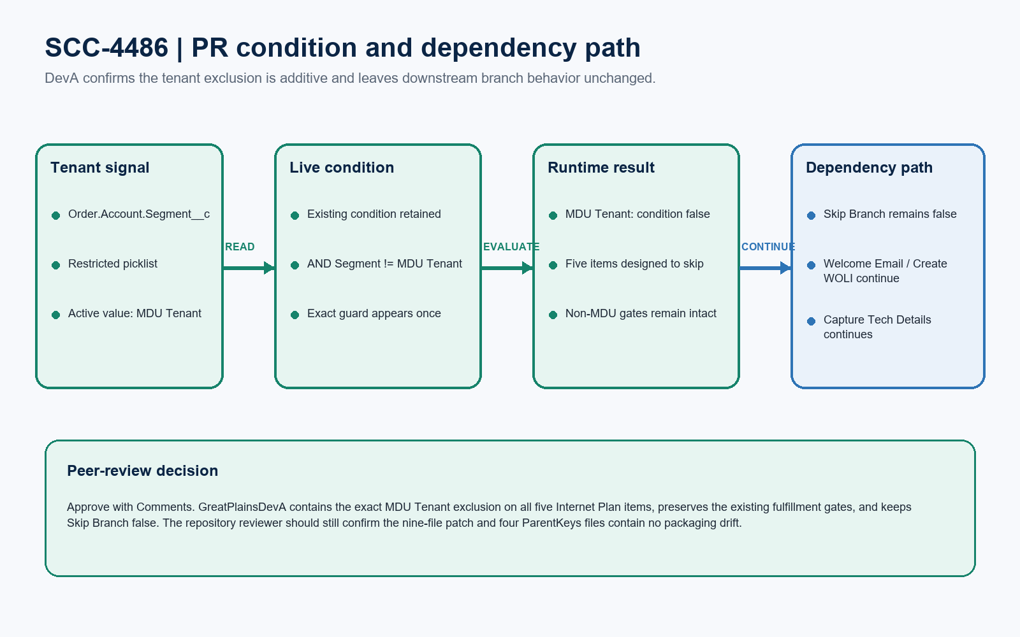
Figure 1. SCC-4486 PR condition and dependency path
VERIFIED LOGIC
Observed on all five items: ExistingCondition AND (Order.Account.Segment__c != 'MDU Tenant'). Each guard uses picklist / field-OrderItem tokens, appears exactly once, and is the final top-level AND clause.

PR findings and reviewer comments
Result | Finding | Reviewer evidence / action
Pass | Authoritative discriminator | The implementation correctly uses Order.Account.Segment__c with the active restricted-picklist value MDU Tenant; it does not depend on nullable MDU identifier strings.
Pass | Condition direction | The != operator makes the full top-level AND condition false for MDU Tenant, which is the correct direction for an automatic Skipped state.
Pass | Existing-condition preservation | The original appointment or drop gates remain present. No live evidence shows that the SCC-4486 change replaced the existing boolean tree.
Pass | Dependency safety | IsSkipBranch remains false. Book Appointment still gates Triage, Welcome Email, and Create WOLI; the drop chain continues through Capture Tech Details.
Comment | Repository diff and ParentKeys | Before merge, confirm the PR is limited to five DataPack.json and four ParentKeys.json files, keeps stable keys, and contains no environment-specific record IDs.
Comment | Blank Segment behavior | Account.Segment__c is nullable. The PR logic is appropriate, but the normal-order expectation for blank Segment should remain covered by the team's separate test process.
Comment | Product relationship paths | Install Drop uses Product2.ProductCode; the other three drop definitions use vlocity_cmt__Product2Id__r.ProductCode. Preserve this pre-existing distinction unless separately justified.
Pass | No code expansion | No Apex, Flow, trigger, API, field, or permission change is required for this story. Reject unrelated automation or schema changes in the PR.

REVIEWER DISPOSITION
No blocking code or live configuration defect was found in GreatPlainsDevA. Approve with Comments, subject to a final repository check that the nine declared files faithfully represent this verified state.

Five-DataPack live evidence
DataPack | Observed DevA condition | Result / GlobalKey
Book Appointment | Appointment status + Segment != MDU Tenant | Pass | Skip Branch false | 86d713dd-cd8a-7c69-091f-d3d2f4f5f4a9
Triage, Prep-Work & Sitewalk | Install method + facility + product + Segment guard | Pass | Skip Branch false | 01c083d3-0a02-24ec-f2a4-1e4a1fee347e
Notify 811 | Install method + facility + product + Segment guard | Pass | Skip Branch false | 274e769c-e9a9-ec1f-d782-d4fa8ed280f4
Install Drop | Install method + facility + Product2.ProductCode + Segment guard | Pass | Skip Branch false | ce652191-615d-84a5-22aa-6ba800141153
Splice and Cutover Drop | Install method + facility + product + Segment guard | Pass | Skip Branch false | 409ef12f-c6b1-06b7-a79e-655e04fad8da

DataPack and ParentKeys controls
Control | Peer-review expectation
Definition identity | All five records are Internet Plan / ManualTask definitions using the orderItems node. The deprecated Condition field is null.
ConditionData | All five use a top-level AND and contain exactly one MDU guard with picklist, field-OrderItem, !=, and MDU Tenant tokens.
Dependencies | Internet Plan links remain: Book -> Triage / Welcome Email / Create WOLI; Triage -> Notify 811 -> Install Drop -> Splice -> Capture Tech Details.
ParentKeys | Four ParentKeys source files are declared by the ticket but are not separately represented as Salesforce records. Verify them in the actual PR patch.
Change history | All five Internet Plan definitions were modified by Naveen Kumar on 25 August 2026; same-name CRC/FSL definitions are separate and unchanged by this review.
Scope discipline | No Apex, Flow, trigger, schema, permission, implementation reference, or Skip Branch change is needed for SCC-4486.

PR-ONLY BOUNDARY
This is a PR/configuration review only. Read-only DevA schema and record evidence was inspected, including existing MDU Tenant orders. No IT test, UAT execution, orchestration run, deployment validation, activation, or org write is claimed.

Reviewer completion checks
# | Review check | Status | Evidence / final action
1 | Five live definitions | Pass | Correct Internet Plan records, exact MDU guard once per item, original gates retained.
2 | Tenant discriminator | Pass | Order.Account.Segment__c; restricted picklist; active exact value MDU Tenant.
3 | Branch and dependency safety | Pass | IsSkipBranch=false on all five and the expected Internet Plan dependency records remain.
4 | Nine-file PR scope | Review comment | Confirm exactly five DataPack.json plus four ParentKeys.json files and no unrelated regenerated JSON.
5 | Key and ID integrity | Review comment | Match the five GlobalKeys above; ParentKeys must use stable keys and exported files must not introduce DevA record IDs.
6 | Final disposition | Approve with Comments | No blocking live logic issue; complete the repository-only checks before merge.

Ready-to-paste PR review response
PR COMMENT
PR review completed for SCC-4486 against GreatPlainsDevA (00DEa00000Fc086MAB) - Approve with Comments. All five Internet Plan ManualTask definitions contain the exact top-level guard Order.Account.Segment__c != 'MDU Tenant'. Book Appointment retains its appointment-status condition, the four drop tasks retain their installation, facility, and product conditions, and IsSkipBranch remains false on every item. The expected Internet Plan dependencies are also present, so no blocking code or live configuration issue was found. Before merge, confirm the PR contains only the five DataPack.json and four ParentKeys.json files, matches the verified GlobalKeys, preserves stable ParentKeys, and introduces no DevA record IDs or unrelated JSON churn. No Apex, Flow, trigger, schema, or permission change is required. This was PR review only: no IT/UAT execution, deployment, activation, orchestration run, record write, or metadata change was performed.

